*Beschrijvende statistiek*

df$**conditie: 1 Corticosteron (rat)**

value proportie

Min. : 8.0 Min. :0.0000

1st Qu.:27.5 1st Qu.:0.1858

Median :44.5 Median :0.5238

Mean :43.5 Mean :0.4261

3rd Qu.:64.0 3rd Qu.:0.6506

Max. :75.0 Max. :0.7400

-----------------------------------------------------------------------------

df$**conditie: 2 Mifepreston**

value proportie

Min. : 24.00 Min. :0.2911

1st Qu.: 40.00 1st Qu.:0.5625

Median : 74.00 Median :0.7976

Mean : 67.33 Mean :0.7022

3rd Qu.: 84.00 3rd Qu.:0.8594

Max. :128.00 Max. :0.9932

-----------------------------------------------------------------------------

df$**conditie: 3 Geldanamycine (17-AAG)**

value proportie

Min. : 8 Min. :0.007937

1st Qu.:32 1st Qu.:0.101320

Median :43 Median :0.200000

Mean :40 Mean :0.288726

3rd Qu.:51 3rd Qu.:0.484738

Max. :63 Max. :0.641026

-----------------------------------------------------------------------------

df$**conditie: negatieve controle (n)**

value proportie

Min. : 12.00 Min. :0.00000

1st Qu.: 33.50 1st Qu.:0.04289

Median : 42.00 Median :0.11404

Mean : 47.95 Mean :0.16770

3rd Qu.: 56.50 3rd Qu.:0.23699

Max. :108.00 Max. :0.53125

-----------------------------------------------------------------------------

df$**conditie: positieve controle (p)**

value proportie

Min. : 20.00 Min. :0.09091

1st Qu.: 31.50 1st Qu.:0.45139

Median : 49.00 Median :0.57500

Mean : 68.68 Mean :0.58634

3rd Qu.:111.50 3rd Qu.:0.74582

Max. :147.00 Max. :0.92857

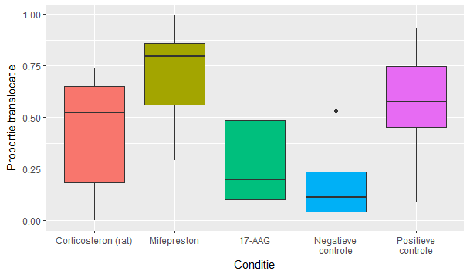

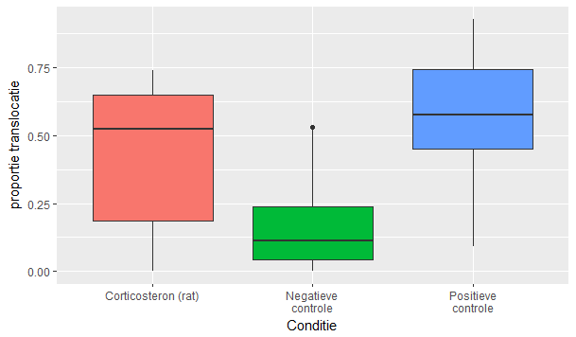

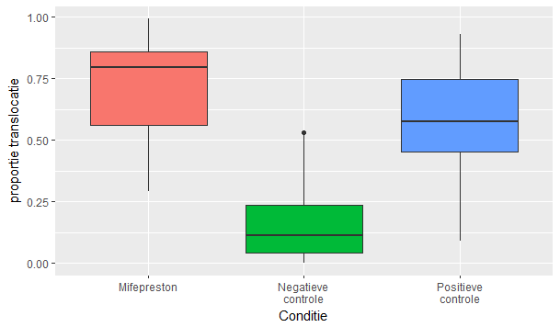

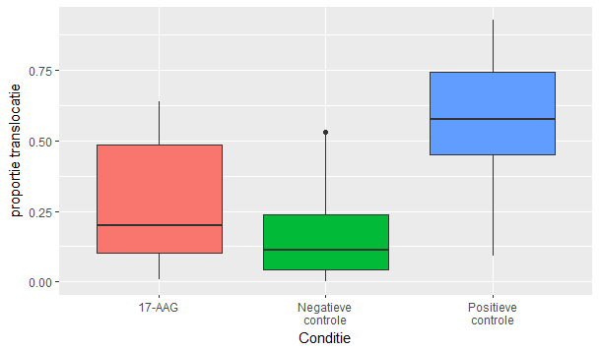

*Assumpties*

Normaliteit (H0: de verdeling is normal-verdeeld)

df$**conditie: 1 Corticosteron (rat)**

Shapiro-Wilk normality test

data: dd[x, ]

W = 0.88795, p-value = 0.2239

-----------------------------------------------------------------------------

df$**conditie: 2 Mifepreston**

Shapiro-Wilk normality test

data: dd[x, ]

W = 0.92817, p-value = 0.4642

-----------------------------------------------------------------------------

df$**conditie: 3 Geldanamycine (17-AAG)**

Shapiro-Wilk normality test

data: dd[x, ]

W = 0.90935, p-value = 0.3914

-----------------------------------------------------------------------------

df$**conditie: negatieve controle (n)**

Shapiro-Wilk normality test

data: dd[x, ]

W = 0.82031, p-value = 0.002289

-----------------------------------------------------------------------------

df$**conditie: positieve controle (p)**

Shapiro-Wilk normality test

data: dd[x, ]

W = 0.97361, p-value = 0.8456

Homogeniteit van variantie (H0: de varianties van alle groepen zijn homogeen)

Testing homogeneity of variance for all conditions

classical Levene's test based on the absolute deviations from the mean ( none not applied because the

location is not set to median )

data: df$proportie

Test Statistic = 1.6908, p-value = 0.1647

Voor het labjournaal testen ze 1 van de volgende drie condities:

**Corticosteron (rat) vs controles**

Testing homogeneity of variance for condition 1 and controls

classical Levene's test based on the absolute deviations from the mean ( none not applied because the

location is not set to median )

data: x$proportie

Test Statistic = 2.4999, p-value = 0.09395

-----------------------------------------------------------------------------

**Mifepreston vs controles**

Testing homogeneity of variance for condition 2 and controls

classical Levene's test based on the absolute deviations from the mean ( none not applied because the

location is not set to median )

data: x$proportie

Test Statistic = 1.3462, p-value = 0.2707

-----------------------------------------------------------------------------

**Geldanamycine (17-AAG) vs controles**

Testing homogeneity of variance for condition 3 and controls

classical Levene's test based on the absolute deviations from the mean ( none not applied because the

location is not set to median )

data: x$proportie

Test Statistic = 1.2597, p-value = 0.2942

*Hypothese toets*

Kruskal-Wallis rank sum test (H0: rank1=rank2=rank3=rank4=rank5)

**All conditions**

Kruskal-Wallis rank sum test

data: df$proportie by df$conditie

Kruskal-Wallis chi-squared = 27.53, df = 4, p-value = 1.553e-05

Voor het labjournaal per conditie:

**Corticosteron (rat) vs controles**

Kruskal-Wallis test for condition 1 and controls

Kruskal-Wallis rank sum test

data: x$proportie by x$conditie

Kruskal-Wallis chi-squared = 19.232, df = 2, p-value = 6.664e-05

-----------------------------------------------------------------------------

df$**conditie: 2 Mifepreston**

Kruskal-Wallis test for condition 2 and controls

Kruskal-Wallis rank sum test

data: x$proportie by x$conditie

Kruskal-Wallis chi-squared = 25.253, df = 2, p-value = 3.283e-0

-----------------------------------------------------------------------------

df$**conditie: 3 Geldanamycine (17-AAG)**

Kruskal-Wallis test for condition 3 and controls

Kruskal-Wallis rank sum test

data: x$proportie by x$conditie

Kruskal-Wallis chi-squared = 20.232, df = 2, p-value = 4.043e-05

*Posthoc vergelijkingen*

Pairwise comparisons using Tukey and Kramer (Nemenyi) test

with Tukey-Dist approximation for independent samples

data: df$proportie and df$conditie

1 2 3 n

2 0.37270 - - -

3 0.90098 0.06166 - -

n 0.25861 0.00020 0.90440 -

p 0.70806 0.91898 0.16007 0.00019

Voor het labjournaal:

**Corticosteron (rat) vs controles**

1 n

n 0.094 -

p 0.408 3.8e-05

-----------------------------------------------------------------------------

df$**conditie: 2 Mifepreston**

2 n

n 7.6e-05 -

p 0.68 7.9e-05

-----------------------------------------------------------------------------

df$**conditie: 3 Geldanamycine (17-AAG)**

3 n

n 0.623 -

p 0.052 2.8e-05