# thuisopdracht boxplot maken in excel

In je onderzoeksverslag hoort een figuur te staan met daarin de waardes van alle vijf experimentele condities. Deze moet je zelf maken.

Het leerdoel van deze opdracht is:

* Je weet hoe je een boxplot moet maken in excel met de data van het Celbiologie practicum.

**Opdracht:**

*Stof*

* AVvIS addendum 9B *onderzoeksverslag*
* Statistiekboek *The analysis of Biological Data* H2.3 (p43-46) en H3.2 (p73-77)

Volg dit stappenplan om zelf een boxplot te maken in excel. Doe dit in het excel bestand dat bij deze opdracht hoort. Controleer met addendum 9B van de AVvIS of het uiteindelijke figuur voldoet aan de inlevereisen. **Let op**: onderstaand stappenplan is gemaakt met behulp van een engelse excel. Als je zelf de nederlandse versie hebt, moet je de vertaling van de formules opzoeken.

1. **Kijk in je statistiekboek wat een boxplot precies representeert. Denk eraan dat je je uiteindelijke figuur kritisch checkt. Kloppen de waardes die erin staan?**
2. **Vul de gele vlakken in met behulp van het output-bestand dat je bij celbiologie hebt gekregen.**
3. **Select the data for the boxes in the box-and-whisker plot.**

In this worksheet, that’s C13:G15. You don’t need rows 12 and 16 in this step.

1. **Select INSERT | Recommended Charts, and then select the sixth option to add a stacked column chart to the worksheet (see figure 1 and 2).**

The fourth option in the Recommended Charts is also a stacked column chart. Don’t select that one. Its rows and columns are reversed.

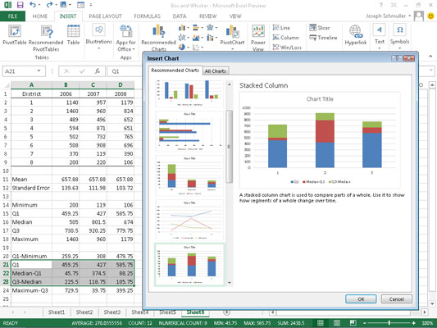

Figure 1. Window you should see after selecting INSERT | Recommended Charts | stacked column chart.

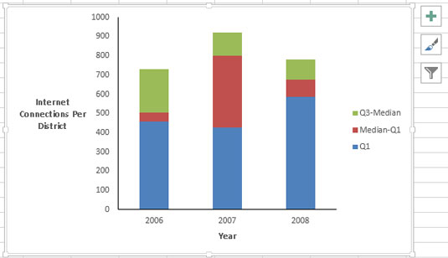

**Figure 2.** This is what the stacked column chart looks like after you insert it, delete the gridlines, move the legend, remove “Chart Title,” and reformat and title the axes. You can do this by using the chart toolset to right of the chart.

1. **Add the whiskers.**

First, add the lower whiskers. With the bars corresponding to Q1 selected (the lowest portion of each stacked column), click the Plus Sign in the chart toolset. From the pop-up menu that appears, select the Error Bars check box, and then the arrowhead to the right of that option. From the resulting menu, select More Options (figure 3).  
This opens the Format Error Bars panel. Select the Minus radio button, the Cap radio button, and the Custom radio button. 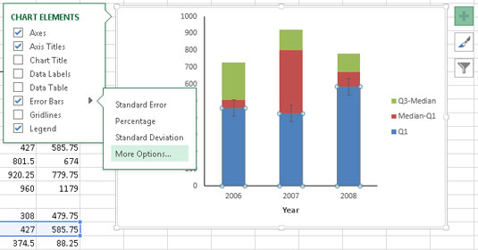

Figure 3. Window you should see after following the first half of step 4.  
  
Then click the Specify Value button to open the Custom Error Bars dialog box. Leaving the Positive Error Value as is, specify the cell range for the Negative Error Value. For this worksheet, that’s C12-G12 (Q1-Minimum).

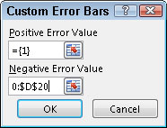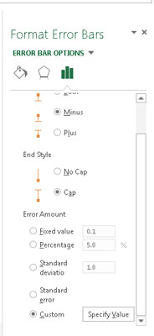

Figure 4. Window you should see after following the second half of step 4.

1. **Clicking OK closes this dialog box, and clicking the Close symbol closes the Format Error Bars panel.**

Follow similar steps to add the upper whiskers. This time select the part of the stacked columns corresponding to Q3-Median (the upper portion of each stacked column). Then as earlier, click the Plus Sign in the chart toolset.

Again, select the box next to Error Bars in the pop-up menu, and the arrowhead to the right of that option. This time in the Format Error Bars panel, select the Plus radio button, the Cap radio button, and the Custom radio button.

Again, click the Specify Value button to open the Custom Error Bars dialog box. This time, specify the cell range for the Positive Error Value. That cell range is C16-G16 (Max-Q3). Click OK and Close. Your chart should now look like figure 5.

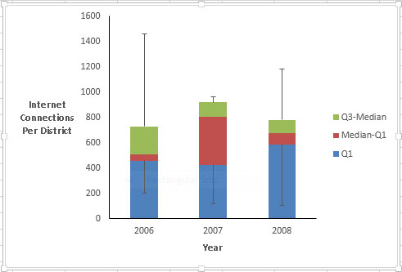Figure 5. Your chart after you have followed step 5.

1. **Make the bottom segments disappear.**

To give the appearance of boxes rather than stacked columns, select Q1 (the bottom portion of each column), then right-click and choose Format Data Series from the pop-up menu to open the Format Data Series dialog box.

In the Format Data Series panel, click Fill (the bucket icon), and in the Fill area select the No Fill radio button. Then in the Border area, select the No Line radio button.

Clicking Close closes the Format Data Series panel. Your chart should now look like figure 6.

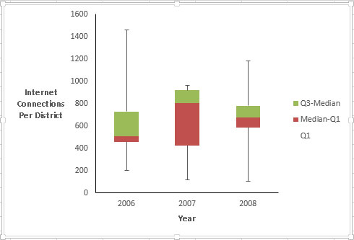

Figure 6. Your chart after you have followed step 6.

1. **Reformat the remaining series to complete the box-and-whiskers plot.**

Select Median-Q1 (the portion that now appears to be the lower part of each column), right-click and pick Format Data Series from the pop-up menu. In the Format Data Series panel, select Fill and select the No Fill radio button in the Fill area. Then select the Solid Line radio button in the Border area.

Next select Border Color and select the Solid Line radio button. Click the Color Button and select black from the Theme Colors palette.

Finally, select Q3-Median (the upper portion of each column), and then go through the same sequence.

After that, delete the legend. Your chart should now look like Figure 7. You can add another data series that shows where the means are, and another that would allow you to connect the medians, but this is enough for now.

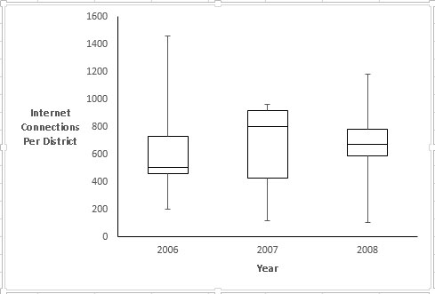

Figure 7. Your final chart.