Maandag P1-P4

F-statistic: 18.27 on 4 and 71 DF, p-value: 2.337e-10

Kruskal Wallis: 46.81, df = 4, p-value = 1.67e-09

Dinsdag P5-P10

F-statistic: 31.55 on 4 and 77 DF, p-value: 1.482e-15

Kruskal Wallis: 60.007, df = 4, p-value = 2.891e-12

Woensdag P11-15

F-statistic: 22.93 on 4 and 64 DF, p-value: 8.752e-12

Kruskal Wallis: 37.31, df = 4, p-value = 1.555e-07

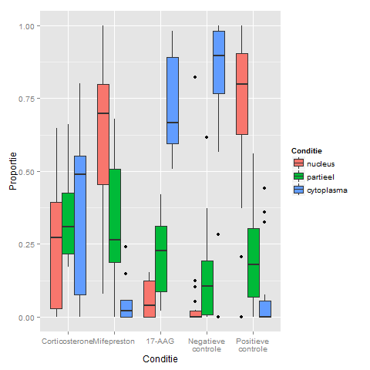

Maandag

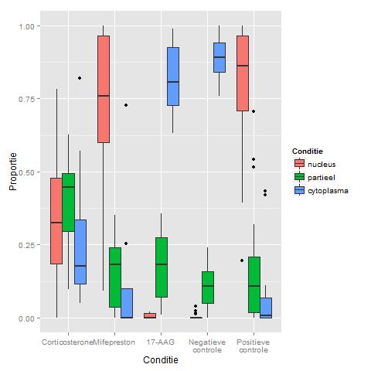

Dinsdag

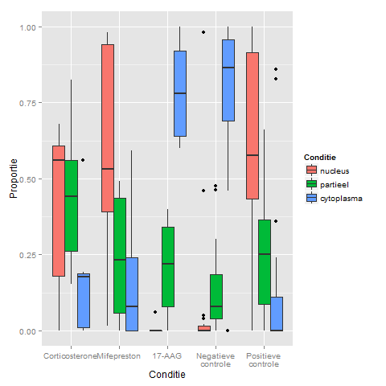

Woensdag