*Beschrijvende statistiek*

df$**conditie: 1 Corticosteron (rat)**

dekglas conditie value proportie

Min. : 1.00 1:11 Min. : 5.00 Min. :0.09091

1st Qu.: 3.50 2: 0 1st Qu.:17.00 1st Qu.:0.49195

Median : 6.00 3: 0 Median :29.00 Median :0.75000

Mean :13.45 n: 0 Mean :33.82 Mean :0.66000

3rd Qu.: 8.50 p: 0 3rd Qu.:47.50 3rd Qu.:0.84888

Max. :93.00 Max. :73.00 Max. :0.97619

---------------------------------------------------------------

df$**conditie: 2 Mifepreston**

dekglas conditie value proportie

Min. :11.00 1:0 Min. : 7.00 Min. :0.009709

1st Qu.:13.00 2:9 1st Qu.: 35.00 1st Qu.:0.071429

Median :15.00 3:0 Median : 53.00 Median :0.611111

Mean :31.67 n:0 Mean : 55.67 Mean :0.439271

3rd Qu.:19.00 p:0 3rd Qu.: 67.00 3rd Qu.:0.785714

Max. :92.00 Max. :103.00 Max. :0.857143

---------------------------------------------------------------

df$**conditie: 3 Geldanamycine (17-AAG)**

dekglas conditie value proportie

Min. :20.00 1:0 Min. :16.00 Min. :0.00000

1st Qu.:23.25 2:0 1st Qu.:35.25 1st Qu.:0.00000

Median :25.50 3:8 Median :54.00 Median :0.03730

Mean :32.62 n:0 Mean :49.38 Mean :0.07508

3rd Qu.:27.25 p:0 3rd Qu.:63.25 3rd Qu.:0.10026

Max. :90.00 Max. :75.00 Max. :0.28125

---------------------------------------------------------------

df$**conditie: negatieve controle (n)**

dekglas conditie value proportie

Min. :29.00 1: 0 Min. : 6.00 Min. :0.00000

1st Qu.:35.00 2: 0 1st Qu.: 23.00 1st Qu.:0.01000

Median :41.00 3: 0 Median : 28.00 Median :0.08772

Mean :44.04 n:25 Mean : 41.03 Mean :0.15104

3rd Qu.:48.00 p: 0 3rd Qu.: 50.00 3rd Qu.:0.17742

Max. :88.00 Max. :111.00 Max. :0.81522

---------------------------------------------------------------

df$**conditie: positieve controle (p)**

dekglas conditie value proportie

Min. :56.0 1: 0 Min. : 4.00 Min. :0.03788

1st Qu.:63.0 2: 0 1st Qu.: 32.00 1st Qu.:0.21930

Median :73.0 3: 0 Median : 57.00 Median :0.38889

Mean :71.9 n: 0 Mean : 59.76 Mean :0.39836

3rd Qu.:80.0 p:21 3rd Qu.: 79.00 3rd Qu.:0.54688

Max. :86.0 Max. :135.00 Max. :0.88889

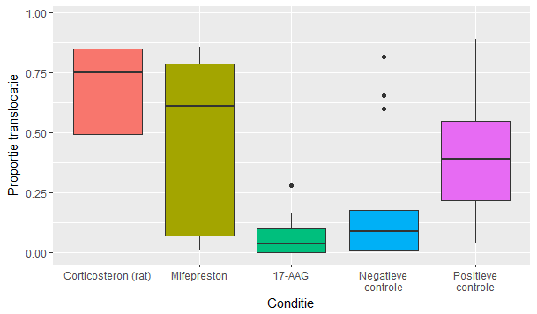

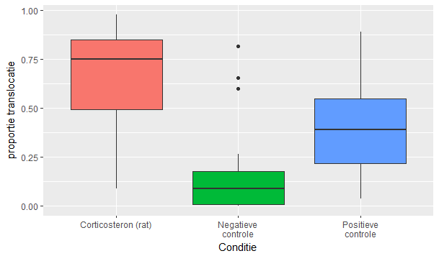

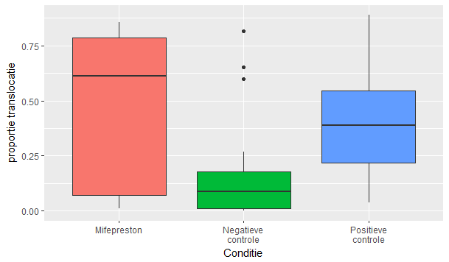

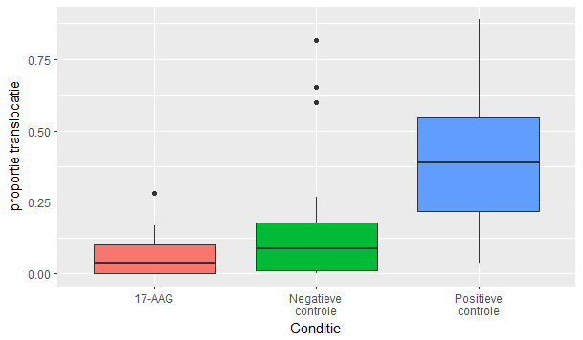

*Assumpties*

Normaliteit (H0: de verdeling is normal-verdeeld)

df$**conditie: 1 Corticosteron (rat)**

W = 0.92877, p-value = 0.3985

-----------------------------------------------------------------------------

df$**conditie: 2 Mifepreston**

W = 0.79918, p-value = 0.01998

-----------------------------------------------------------------------------

df$**conditie: 3 Geldanamycine (17-AAG)**

W = 0.79491, p-value = 0.02524

-----------------------------------------------------------------------------

df$**conditie: negatieve controle (n)**

W = 0.69019, p-value = 5.394e-06

-----------------------------------------------------------------------------

df$**conditie: positieve controle (p)**

W = 0.96426, p-value = 0.6057

Homogeniteit van variantie (H0: de varianties van alle groepen zijn homogeen)

Test Statistic = 5.3559, p-value = 0.0008149

Voor het labjournaal testen ze 1 van de volgende drie condities:

**Corticosteron (rat) vs controles**

Test Statistic = 1.2612, p-value = 0.2915

-----------------------------------------------------------------------------

**Mifepreston vs controles**

Test Statistic = 6.7429, p-value = 0.00249

-----------------------------------------------------------------------------

**Geldanamycine (17-AAG) vs controles**

Test Statistic = 2.4252, p-value = 0.0986

*Hypothese toets*

Kruskal-Wallis rank sum test (H0: rank1=rank2=rank3=rank4=rank5)

Kruskall-Wallis test for all conditions

Kruskal-Wallis rank sum test

data: df$proportie by df$conditie

Kruskal-Wallis chi-squared = 28.557, df = 4, p-value = 9.617e-06

**All conditions**

Voor het labjournaal per conditie:

**Corticosteron (rat) vs controles**

Kruskal-Wallis chi-squared = 23.08, df = 2, p-value = 9.733e-06

-----------------------------------------------------------------------------

df$**conditie: 2 Mifepreston**

Kruskal-Wallis chi-squared = 12.816, df = 2, p-value = 0.001648

-----------------------------------------------------------------------------

df$**conditie: 3 Geldanamycine (17-AAG)**

Kruskal-Wallis chi-squared = 17.318, df = 2, p-value = 0.0001735

*Posthoc vergelijkingen*

1 2 3 n

2 0.53780 - - -

3 0.00051 0.10476 - -

n 0.00017 0.17042 0.93365 -

p 0.42694 0.99992 0.02376 0.01631

Voor het labjournaal:

**Corticosteron (rat) vs controles**

1 n

n 1.9e-05 -

p 0.1597 0.0038

-----------------------------------------------------------------------------

df$**conditie: 2 Mifepreston**

2 n

n 0.0582 -

p 0.9574 0.0021

-----------------------------------------------------------------------------

df$**conditie: 3 Geldanamycine (17-AAG)**

3 n

n 0.6969 -

p 0.0025 0.0010