*Beschrijvende statistiek*

df$**conditie: 1 Corticosteron (rat)**

value proportie

Min. : 5.00 Min. :0.3929

1st Qu.:14.00 1st Qu.:0.4797

Median :23.50 Median :0.5379

Mean :25.50 Mean :0.5777

3rd Qu.:35.25 3rd Qu.:0.6979

Max. :50.00 Max. :0.8261

-----------------------------------------------------------------------------

df$**conditie: 2 Mifepreston**

value proportie

Min. :14.0 Min. :0.2656

1st Qu.:22.0 1st Qu.:0.5386

Median :42.5 Median :0.7416

Mean :41.3 Mean :0.6779

3rd Qu.:57.0 3rd Qu.:0.8558

Max. :69.0 Max. :0.9643

-----------------------------------------------------------------------------

df$**conditie: 3 Geldanamycine (17-AAG)**

value proportie

Min. :19.0 Min. :0.008197

1st Qu.:27.0 1st Qu.:0.106725

Median :41.5 Median :0.181179

Mean :43.7 Mean :0.202608

3rd Qu.:58.0 3rd Qu.:0.285740

Max. :75.0 Max. :0.46296

-----------------------------------------------------------------------------

df$**conditie: negatieve controle (n)**

value proportie

Min. : 5.00 Min. :0.000000

1st Qu.: 22.25 1st Qu.:0.005435

Median : 33.00 Median :0.058571

Mean : 37.50 Mean :0.115134

3rd Qu.: 50.00 3rd Qu.:0.179842

Max. :108.00 Max. :0.650000

-----------------------------------------------------------------------------

df$**conditie: positieve controle (p)**

value proportie

Min. : 6.00 Min. :0.2907

1st Qu.: 24.75 1st Qu.:0.5952

Median : 48.00 Median :0.8130

Mean : 47.17 Mean :0.7392

3rd Qu.: 60.50 3rd Qu.:0.9137

Max. :106.00 Max. :1.0000

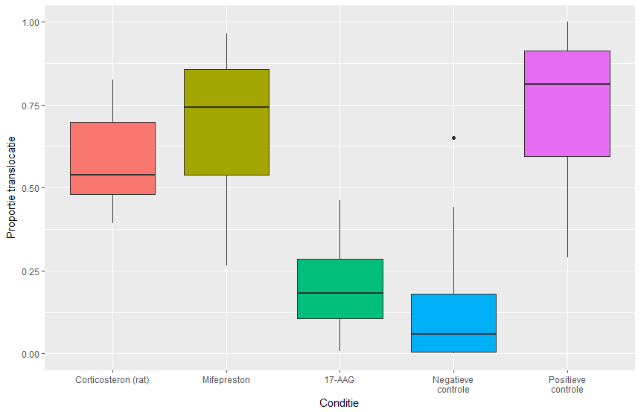

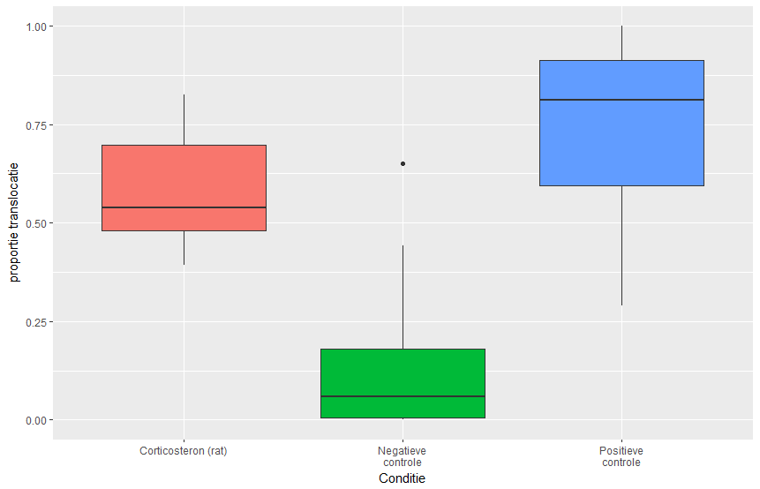

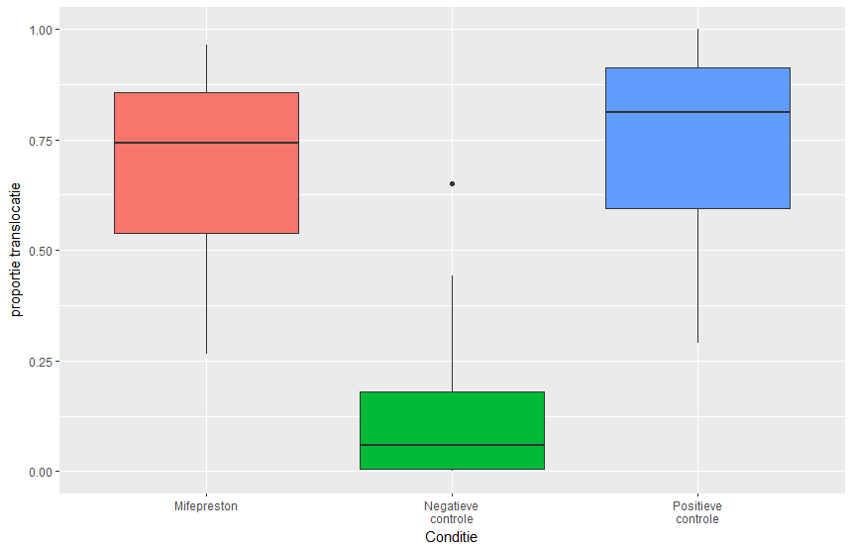

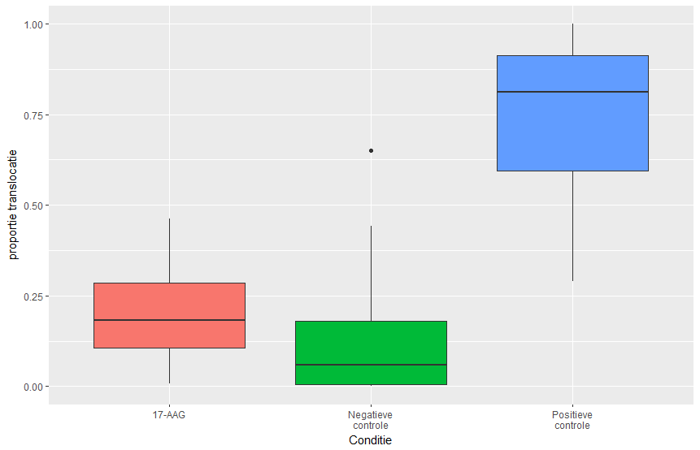

*Assumpties*

Normaliteit (H0: de verdeling is normal-verdeeld)

df$**conditie: 1 Corticosteron (rat)**

Shapiro-Wilk normality test

data: dd[x, ]

W = 0.87134, p-value = 0.1036

-----------------------------------------------------------------------------

df$**conditie: 2 Mifepreston**

Shapiro-Wilk normality test

data: dd[x, ]

W = 0.93742, p-value = 0.5247

-----------------------------------------------------------------------------

df$**conditie: 3 Geldanamycine (17-AAG)**

Shapiro-Wilk normality test

data: dd[x, ]

W = 0.94885, p-value = 0.655

-----------------------------------------------------------------------------

df$**conditie: negatieve controle (n)**

Shapiro-Wilk normality test

data: dd[x, ]

W = 0.74347, p-value = 7.156e-06

-----------------------------------------------------------------------------

df$**conditie: positieve controle (p)**

Shapiro-Wilk normality test

data: dd[x, ]

W = 0.89255, p-value = 0.005546

Homogeniteit van variantie (H0: de varianties van alle groepen zijn homogeen)

**Testing homogeneity of variance for all conditions**

Test Statistic = 3.1849, p-value = 0.01729

Voor het labjournaal testen ze 1 van de volgende drie condities:

**Corticosteron (rat) vs controles**

Test Statistic = 4.5931, p-value = 0.01351

-----------------------------------------------------------------------------

**Mifepreston vs controles**

Test Statistic = 4.8403, p-value = 0.01088

-----------------------------------------------------------------------------

**Geldanamycine (17-AAG) vs controles**

Test Statistic = 4.872, p-value = 0.01058

*Hypothese toets*

Kruskal-Wallis rank sum test (H0: rank1=rank2=rank3=rank4=rank5)

Kruskall-Wallis test for all conditions

Kruskal-Wallis rank sum test

data: df$proportie by df$conditie

Kruskal-Wallis chi-squared = 62.165, df = 4, p-value = 1.017e-12

**All conditions**

Voor het labjournaal per conditie:

**Corticosteron (rat) vs controles**

Kruskal-Wallis rank sum test

data: x$proportie by x$conditie

Kruskal-Wallis chi-squared = 48.33, df = 2, p-value = 3.201e-11

-----------------------------------------------------------------------------

df$**conditie: 2 Mifepreston**

Kruskal-Wallis rank sum test

data: x$proportie by x$conditie

Kruskal-Wallis chi-squared = 47.129, df = 2, p-value = 5.835e-11

-----------------------------------------------------------------------------

df$**conditie: 3 Geldanamycine (17-AAG)**

Kruskal-Wallis rank sum test

data: x$proportie by x$conditie

Kruskal-Wallis chi-squared = 48.212, df = 2, p-value = 3.396e-11

*Posthoc vergelijkingen*

**All conditions**

Pairwise comparisons using Tukey and Kramer (Nemenyi) test

with Tukey-Dist approximation for independent samples

data: df$proportie and df$conditie

1 2 3 n

2 0.96816 - - -

3 0.14955 0.02824 - -

n 0.00131 4.2e-05 0.85017 -

p 0.70748 0.98854 0.00045 6.5e-12

p-n 0.6240506 0.48846200 0.7596393 0.0000000

Voor het labjournaal:

**Corticosteron (rat) vs controles**

1 n

n 0.0013 -

p 0.3785 2.2e-11

-----------------------------------------------------------------------------

df$**conditie: 2 Mifepreston**

2 n

n 9.7e-05 -

p 0.87 1.5e-10

-----------------------------------------------------------------------------

df$**conditie: 3 Geldanamycine (17-AAG)**

3 n

n 0.4036 -

p 0.0011 2.5e-11