**Keeping up with the Joneses?**

**Neighborhood effects on the vote**

*Eelco Harteveld and Wouter van der Brug*

**Abstract**

Voters do not make their vote choices in social isolation, but are affected by cues from their immediate social environment. One of these cues consists of the political opinions available and accepted in people’s neighborhoods, which are theoretically expected to affect vote choices through so-called “conversion by conversation”. However, so far data-limitations have impeded our abilities to establish whether electoral preferences of voters are indeed influenced by the electoral preferences of their neighbors. Using geo-coded panel data from the Netherlands, we are able to assess the effect of the level of support for parties in a neighborhood on the subsequent vote choices of individuals, while controlling for their previous vote choice. We find that there are clear neighborhood effects, but only for those voters who feel strongly embedded in the local community. Once ‘neighborhood embeddedness’ is controlled for, we find no differences between people who recently moved into a neighborhood and those who lived in that neighborhood for a longer period of time. This suggests that electoral decisions are not just influenced by the political preferences of neighbors, but also that people move to neighborhoods with like-minded people.

**Introduction**

In this study we assess whether electoral decisions of individual voters are affected by the political preferences of citizens in their neighborhood. Scholars have argued for a long time that electoral decisions are influenced by the political preferences of voters’ social environment (e.g., Festinger 1962; Cox 1969). The causal mechanism has been summarized as ‘conversion through conversation’ (e.g., Miller 1978; Pattie and Johnston 1999). People discuss politics with others in their social environment and to the extent that they influence each other’s political opinions, their opinions become more aligned. Various scholars have produced evidence of effects of the immediate social context on voting decisions. This has been shown for various contexts, such as church congregations (e.g., Huckfeld and Sprague, 1995), the workplace (e.g., Mutz and Mondak, 2006) and neighborhoods (e.g., MacAllister et al., 2001; Johnston et al. 2004; 2005; Johnston and Patti 2006). However, some scholars have challenged the conclusions of studies on neighborhood effects. In particular, Gallego et al. (2016) recently concluded on the basis of panel survey data from the UK that contextual effects on the vote are overestimated and are largely the result of ‘geographical sorting’: people moving into neighborhoods with like-minded people. Bishop (2012) made a similar argument for the US.

We agree with Gallego et al. (2016) that neighborhood effects may be overestimated if one does not take into account the fact that a correlation between the voting behavior of individuals and the voting behavior of their neighbors can be produced by ‘geographical sorting’. However, Gallego et al. estimate contextual effects at the level of electoral districts in the UK, which on average have almost 70,000 inhabitants. As the causal mechanism of the neighborhood effect is by means of ‘conversion through conversation’, electoral districts are too large to expect such effects to become visible at this level. By contrast, Johnston et al. (2004) and Johnston et al. (2005) do rely on small geographical units in their study of neighborhood effects in Britain. However, they lack information about the distribution of political preferences in these neighborhoods, so that they have to rely on sociodemographic proxies instead. The same is true for David & Van Hamme (2011) in their study of Belgium. Furthermore, the cross-sectional design of these studies cannot fully rule out confounding factors shaping a correlation between the preferences of individuals and their environments.

In our study, we are able to circumvent these problems, by employing geo-coded panel survey data from the Netherlands. The panel data contain information about the party citizens voted for in the previous election, thus reducing the range of potentially confounding factors. We also have accurate information on the distribution of local political preferences, in the shape of local election results in the neighborhood at the previous election. These neighborhoods have 1,379 inhabitants (624 households) on average, which is a sufficiently small scale to plausibly involve some degree of everyday (political) conversation. These data allow us to assess whether people are more likely to switch to a party that is supported by many people in their neighborhood, or are more likely to abandon a party that receives little support. Finally, in line with Johnston et al. (2005), we use respondents’ (subjective) level of attachment to the neighborhood to investigate the mechanism of conversion by conversation. We find clear effects, but only among voters who say that they feel (strongly) attached to the neighborhood. Our findings thus lend strong support to the idea that the views and preferences of voters’ social context (both those intimately and weakly connected) provide a heuristic which affects their party preferences. Moreover, the fact that neighborhood attachment is such a strong moderator, is clearly consistent with the theory that ‘ conversion by conversation’ is the causal mechanism.

It is important to understand the role of neighborhoods in shaping vote choices. First of all, regional variation in the popularity of parties has been explained mainly by a combination of socio-structural conditions and individual background characteristics. Our study demonstrates that success as well as failures of parties in specific regions can be self-reinforcing. Once a party has become popular in a neighborhood, more people are likely to switch to that party. Secondly, some American scholars have expressed concern about the increasing concentration of the like-minded as a factor causing polarization and harming interparty understanding (Bishop 2012). This ultimately rests not only on selection but also the homogenizing effect neighbors allegedly have on each other. We found clear neighborhood effects in a country with relatively limited regional variations in the popularity of parties and with a highly proportional system. There are no neighborhoods in which one party had an absolute majority. We would expect neighborhood effects to be stronger in the context of a two-party system, which makes it indeed highly plausible that neighborhood effects contribute to political polarization.

**Theory**

Theorizing on the influence of the direct social context on electoral decisions goes back several decades. The idea behind this is plain and simple. People are social animals. As a consequence, they are sensitive to be influenced by people they like and trust. This goes for all sorts of things, such as their taste in clothing, movies, music and books , their basic values, their religious beliefs, the football team they support and, most likely their political party preferences. The more strongly felt some of these attitudes are, the less likely these are to change as a result of the influence of others. Is seems very plausible that religious beliefs are more stable than preferences for clothing, which may change on an annual basis. Some people have stable political party preferences, while others may be more likely to switch and thus to be influenced by people in their direct social environment.

It is plausible that “individuals are inﬂuenced by the nature of the politically relevant information circulating within their social networks, many of which are spatially constrained to their local area” (Pattie & Johnston 2000: 41). Apart from providing shared experiences (i.e., all residents react to building a nuclear plant in the neighborhood) or formal institutions (local unions or newspapers), neighborhoods can also shape political preferences through a “conversion by conversation” or “informal interaction” mechanism (Books and Prysby 1999). In other words, “people who talk together vote together” (Miller 1977: 65; Johnston & Pattie 2018).

The social environment might influence individuals in a number of ways. First, if many people in your neighborhood support a specific party, people who live in that neighborhood will be more likely to hear positive remarks about that party in personal communication. To the extent that someone is sensitive to such arguments, one may acquire a more positive impression of that party and hence become more likely to support it. Second, the sheer fact that many people in a neighborhood support a political party, might signal to other individuals that this party is attractive. Even without direct communication about the party, this positive signal might drive some voters towards this party. Third, when a party is socially stigmatized, some voters who agree with a party on substantive grounds may still not be willing to support it (e.g., Harteveld et al., forthcoming). Examples of a party with a social stigma are in particular some radical right parties and communist parties. When many voters in your neighborhood support a party, this signals to people in this neighborhood that there really is no social stigma. So, voters who would otherwise not support the party, even if they would largely agree with it, may now no longer experience any impediment against supporting it. In sum, we have laid out three mechanisms by which high support in a neighborhood could make a party more attractive to other voters who live in that neighborhood. All three mechanisms can be expected to work in the opposite direction in the case of low support of a party in that neighborhood. Citizens who live in that neighborhood are more likely to hear negative comments, the low support for the party sends a negative signal, and low neighborhood support could reinforce the feeling that a party is stigmatized. Our first hypothesis is therefore:

*H1: Aggregate support for a party in a neighborhood at t-1 will have a positive effect on the likelihood of citizens who live in that neighborhood to switch to that party between t-1 and t.*

We will refer to H1 as the ‘ neighborhood effect hypothesis’. H1 is predicted by all three causal mechanisms discussed above. While our research design allows us to test H1, and thus to establish whether there is indeed a significant neighborhood effects, it does not enable us to observe the exact causal mechanism directly. However, theoretically, we may point to a number of characteristics of voters as well of parties, that would moderate the expected neighborhood effect if some of these mechanisms would play a role. So, while we cannot really test the different mechanisms, we may be able to assess whether some of the mechanisms are more likely than others.

A first moderator of neighborhood effects are the ties that voters have to other people in the neighborhood (Cox 1969). The mechanism of ‘conversion through conversation’ presupposes that such a conversation takes place. In other words, as Johnston et al. (2005) put it: “if local social interaction is the core process involved in the production of neighbourhood effects – which is assumed in many studies although demonstrated in very few (…) – research is needed which establishes that people who interact with their neighbours vote with them, irrespective of their individual characteristics”. They subsequently show that neighborhood effects are indeed larger among people with more “neighborhood social capital”, measured as attachment to and ties with the neighborhood. The associated hypothesis is:

*H2: The neighborhood effect (expected under H1) is strongest among those most embedded in their neighborhood (first order interaction).*

If neighborhoods affect attitudes through exposure and debate, this should be especially the *case among those most strongly embedded in their neighborhood*. So, if H2 is supported, we would conclude that the effect takes place, at least in part, through conversation.

A second variable that could theoretically moderate the neighborhood effect is the *length of residence in a neighborhood* (LOR)*,* albeit that different considerations could lead us to expect opposite patterns. On the one hand, the LOR may be another indicator of the embeddedness in a neighborhood. Those who have lived in a neighborhood for a long time will know more people in the area, so that they are more likely to be influenced by their neighbors. Yet, this effect will be captured to a large extent by the embeddedness of voters in their neighborhood. On the other hand, people who have lived there for a long time, may have been influenced already in the past, or are more likely to be local opinion leaders. This would make them less likely to adapt their party preferences in the direction of the others in their neighborhood. So, while we will test whether an interaction effect exists, we do not have very strong expectations. However, we do have clear expectations about a second order interaction. We expect the strongest effect among people who feel strongly embedded in their neighborhood *and* who only recently moved into the neighborhood. Since they only recently moved in, the potential for neighborhood effects is larger, because those who live there for a long time will have been influenced already (if they are sensitive to that). Yet, whether they will be influenced is likely to depend upon their embeddedness in the neighborhood. So, these consideration lead us to expect a second order interaction:

*H3: The neighborhood effect (expected under H1) is strongest among those who recently moved into the neighborhood and who nevertheless feel embedded in their neighborhood (second order interaction).*

In an indirect way, H3 speaks to a recent debate on political “sorting” (Bishop 2012). This (controversially) concept refers to a growing geographic clustering of like-minded people (in terms of partisanship and ideology, but also regarding education, class, religion, race). This possibly reinforces pre-existing dispositions, creating polarization and inter-party resentment. Our data does not allow us to estimate sorting effects and neighborhood effects in a joint research design. However, by analyzing whether our patterns differ among people who recently arrived in a neighborhood, we will be able to assess whether sorting is an issue. If sorting would be a key process, H3 will not be supported, because recent arrivals are very similar to those already living there. So, in that case the embeddedness in the neighborhood will play a big role (H2),but length of residence should not matter. Yet, if we do find support for H3, we would conclude that the preferences of recent arrivals are relatively *un*like those in their environment. In that case, we would conclude that sorting is not a (major) process in the Netherlands.

So far, we have discussed two individual level moderators. In addition, we have theoretical reasons to expect differences between parties. In particular, we expect that voting for the controversial populist radical right Party for Freedom might be especially sensitive to neighborhood cues. Previous research has shown that voting for such parties is often deterred by the stigma attached to it (Harteveld et al. 2017). Support for a party in the immediate environment might neutralize such a stigma.

*H4: The neighborhood effect (expected under H1) is stronger for the Party for Freedom than for other parties (first order interaction).*

Finally, we will study whether there is an asymmetry in the neighborhood effect caused by (relatively) low versus (relatively) high support for a party in a neighborhood. Relatively low support in a neighborhood could be an obstacle that prevents citizens from voting for a party they would otherwise support. High support in a neighborhood could be an extra stimulus to also support that party. We have no convincing theoretical reasons to expect the positive effect to be stronger than the negative one or vice versa. However, we will explore whether such an asymmetry exists.

**The Netherlands: an unlikely case**

Our study takes place in the Netherlands, which we argue is an unlikely case for observing the hypothesized neighborhood effects. On the one hand, the Netherlands has a very proportional party system and most Dutch citizens do not have a single party that they deeply identify with. While it is quite rare for voters to switch between ideologically dissimilar parties, Van der Meer et al. (2012: 340) show on the basis of a multi-wave panel study that 52 percent of the Dutch voters switched their vote intention at least once over the course of a four year period. So, while ideological predispositions are rather stable, Dutch voters are quite prone to switch between parties, which makes them sensitive to social influences.

On the other hand, the nature of the cues about parties is very different in Dutch neighborhoods compared to systems with two or three (dominant) parties. This is visible in Figure 1, which is based on our dataset of election results per neighborhood (see description below). First, the existence of a plethora of small to medium-sized parties[1] ensures that in few neighborhoods one party utterly dominates the others. In fact, in only 1.82% of the neighborhoods was there a single party which managed to obtain a majority of the votes. Support for the largest party usually hovered between 20% and 40%. Conversely, the fractured nature of the party system also means there is that most parties have at least *some* support almost everywhere: the 8 largest parties obtained votes in all but 1,77% of the neighborhoods. All this means that Dutch voters, in contrast to voters in two-party systems, are hardly ever surrounded by overwhelming support for a party, nor by a total lack of it. This ambiguous nature of local political cues make the Netherlands a less likely case to find the hypothesized neighborhood effects.

*Figure 1*. Support for the smallest and largest of the 8 nationally most important parties in a neighborhood (2012)

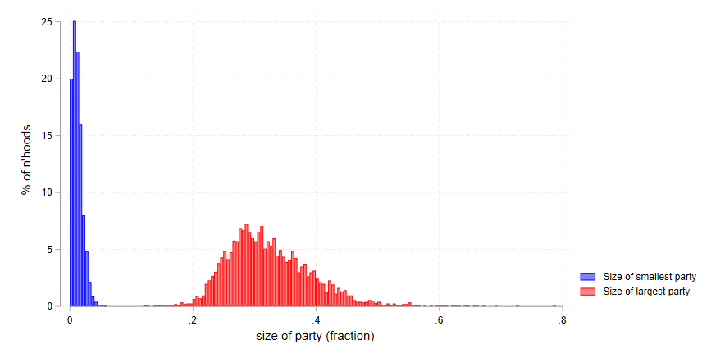

**Data and methods**

*Data*

In this study we employ individual-level survey data , collected in March 2017 immediately after the national elections. The sample was drawn from a pre-existing standing panel of the company GfK, which enabled us to retrieve the vote choice of the majority of the respondents in our data in 2012. The data contains a geocode which allows us to establish in which neighborhood the respondent lives. The neighborhood (*buurt*) is the smallest of the area classification used by *Statistics Netherlands*, with an average population size of 1,379 (on average 624 households). The data on election results in the same area in 2012 is derived from the Dutch Electoral Council (*Kiesraad*). This data consists of aggregate level election results for each polling station. While Dutch citizens are allowed to vote in any polling station in their municipality, we know that a majority do so in the polling station that is closest to their home. The electoral council’s data contains a postal code for about 2/3s of the polling stations. This allowed us to establish the support for each party in the respondent’s neighborhood (averaged across the polling stations if there is more than one).

While the data thus relies on a subsample of the SCoRE participants of which the 2012 vote choice was available, and then again on a subsample of which the polling results of 2012 are known, the large size of the original sample ensures we still end up with a sizeable number of 2,178 respondents. The panel of GfK is not a random sample of the Dutch population. However, since our study does not aim to provide a descriptive account of the Dutch population, but instead aims to test effects, the representativeness of the sample is not a major concern. More crucial is whether there is sufficient variation in the variables included in our model. For this reason, GfK was asked to draw a sample from their larger panel that would be quite representative of the Dutch population on a number of characteristics that are crucial in the context of our specific study, most notably geographical spread and voting behavior in 2017.

*Operationalization*

The key variables on the individual levels are respondents’ vote choices in 2012 and 2017. This is based on reported vote choices at the national elections held in September 2012 and March 2017. Neighborhood embeddedness is measured using the following question: “To what extent do you feel connected to your neighborhood or village?”, with an answer scale ranging from 1 (“Not connected at all”) to 7 (“Strongly connected”). The Length of residence is measured by a question that asks “How long have you lived in your current neighborhood?”, which the respondents answer by providing a number of years. On this basis we distinguished two groups: those who moved into the neighborhood between the previous election and the year in which the survey was fielded (five years) and people who had been living in the same neighborhood for more than 5 years.

*Design*

Investigating neighborhood effects is difficult for three reasons. First, conventional models of vote choice typically rely on surveys without information on the geographical location, so that vote choices are usually modelled without data on the preference distribution in the immediate environment (see Huckfeldt and Sprague 1995 for this critique). To the extent that contextual data are available, these are usually collected for much larger regions or even at the country level. Not at the level of neighborhoods. Second, a mere correlation between an individual’s preferences and those in her or his environment is no evidence for “conversion by the neighborhood”. Such a correlation can be brought about by selection (i.e., individuals with similar preferences ending up in the same neighborhood), or by confounders (developments affecting the entire neighborhood at once). Third, the mechanism is usually not investigated. As noted by Johnson & Pattie (2014), the crucial assumption that “social interaction takes place in localized social networks” is usually not investigated.

Our study has a design that aims to alleviate these problems to a large extent. First, we are able to observe the distribution of preferences in a respondents’ immediate environment by combining geo-coded survey data with the electoral outcomes in respondents’ nearby voting booths. Second, we increase the internal validity with a longitudinal design, in which the neighborhood preferences at *t*1 are used to predict an individual’s choice at *t*2, controlling for this person’s choice at *t*1. In this way we control for all sorts of individual and contextual variables, which could produce spurious relationships. Third, we have good measures of the level of embeddedness of an individual in their neighborhood, which allows us to observe whether these indeed – as the conversion by conversation mechanism predicts – moderate the relationship.

To isolate the neighborhood effects on an individuals’ subsequent vote choices as much as possible, we use the following specification. We create a stacked dataset consisting of *respondent-party dyads*. We did so for the 8 largest parties in the dataset which attracted the votes of at least 100 respondents in 2012: VVD (liberal-conservatives), PvdA (social-democrats), PVV (populist radical right), SP (radical left), CDA (Christian-democrats), D66 (liberal-progressives), CU (orthodox Christians) and GL (greens). We only include respondents who voted for one of these parties in 2012. Figure 2 provides a graphical representation of the distribution of support for these eight parties in our stacked dataset, our key independent variable.

*Figure 2.* Support for parties in neighborhood (party-respondent dyads)

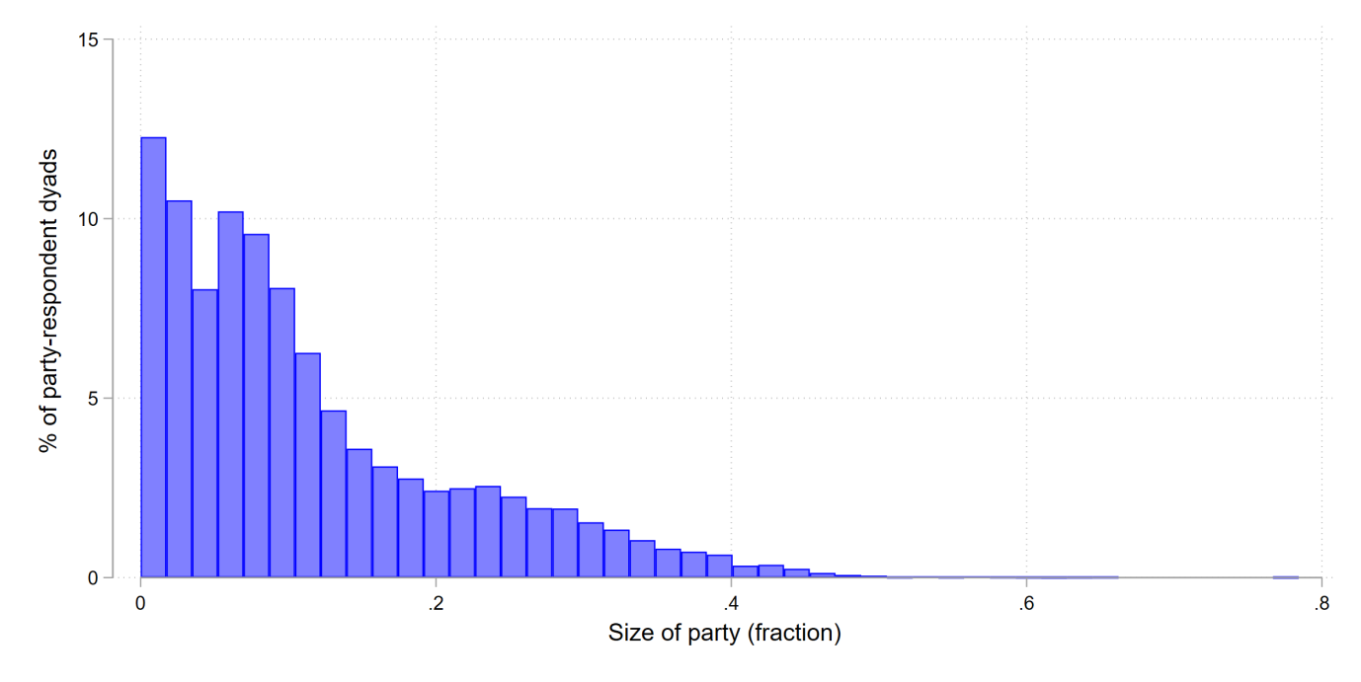

In our main analysis, we use logistic regression to predict whether the respondent voted for the party included in the dyad. We predict this vote choice by the share of support for that party in the respondents’ neighborhood. Importantly, we control for the respondents’ vote choice in 2012. This way, the effect of our neighborhood support variable captures whether, *regardless of a respondent’s vote choice in the previous election*, she or he is more likely to switch to a party if it has considerable support in the neighborhood. To test the mechanism of neighborhood social cues, we interact neighborhood support with neighborhood embeddedness.

Apart from party dummies, all models control for the following socio-demographics and attitudes: self-reported left-right position (dummies for each category of the 11-point scale); nativism (a scale of three items concerning immigration); authoritarianism (a scale of three items about law and order); preference for redistribution; education (low, middle, high); age and its square term; employment status; religiosity; and immigrant status. We include these controls using a procedure proposed by Van der Eijk et al. (2006). This works as follows: we first predict each respondent’s likelihood to vote for a party in separate linear regressions for each party; we subsequently save this predicted probability, and use it (after centering) as an explanatory variable in our subsequent regression. This y-hat is a linear transformation of the original variables, which captures the variation already explained by the socio-demographic and attitudinal variables.

Given the nested structure of our stacked data, we include random intercepts at the level of individuals (level 2) and neighborhoods (level 3). Fixed effects were included for each party, to capture the differences in aggregated support for individual parties. Finally, we applied socio-demographic survey weights as provided by the survey company.

To estimate possible asymmetries, we create a different dependent variable, which takes the values “switching *to* a party”; “switching *away from* a party” and “not changing”. We estimate a multinomial logit model to assess whether these different outcomes are explained by neighborhood support in the same way.

**Results**

Table 1 shows the results of three multilevel logistic regressions in which the vote for a party in 2017 is predicted in our stacked dataset. We discuss the models in turn, using graphs to visualize the first- and second-order interactions of models 2 and 3.

*Table 1*. Multilevel regression

|  |  |  |  |
| --- | --- | --- | --- |
|  | Model 1  *H1* | Model 2  *H2* | Model 3  *H3* |
| Vote in '12 | 2.740** | 2.738** | 2.740** |
|  | (0.112) | (0.112) | (0.112) |
| Support in n’hood in ‘12 | 2.023** | -0.175 | -6.084 |
|  | (0.673) | (1.462) | (4.049) |
| Party (ref: VVD) | 0.000 | 0.000 | 0.000 |
| *PvdA* | -0.855** | -0.853** | -0.868** |
|  | (0.159) | (0.160) | (0.160) |
| *PVV* | 0.870** | 0.868** | 0.859** |
|  | (0.206) | (0.205) | (0.206) |
| *SP* | 0.432* | 0.429* | 0.419* |
|  | (0.194) | (0.194) | (0.194) |
| *CDA* | 0.990** | 0.983** | 0.976** |
|  | (0.208) | (0.208) | (0.209) |
| *D66* | 1.079** | 1.076** | 1.072** |
|  | (0.210) | (0.209) | (0.209) |
| *CU* | 0.144 | 0.138 | 0.126 |
|  | (0.232) | (0.232) | (0.233) |
| *GL* | 1.236** | 1.227** | 1.218** |
|  | (0.226) | (0.226) | (0.227) |
| Y-hat | 7.431** | 7.438** | 7.442** |
|  | (0.283) | (0.283) | (0.284) |
| N’hood attachment |  | -0.034 | -0.105 |
|  |  | (0.031) | (0.085) |
| Support in n’hood X N’hood attachment |  | 0.429+ | 1.358+ |
|  |  | (0.255) | (0.816) |
| Length of residence (5+ yrs) |  |  | -0.543 |
|  |  |  | (0.445) |
| Support in n’hood X Length of residence |  |  | 6.521 |
|  |  |  | (4.287) |
| N’hood attachment X Length of residence |  |  | 0.080 |
|  |  |  | (0.092) |
| Support in n’hood X N’hood attachment X Length of residence |  |  | -1.025 |
|  |  |  | (0.869) |
| Intercept | -3.829** | -3.650** | -3.159** |
|  | (0.224) | (0.273) | (0.465) |
| Var (n’hood) | 0.000** | 0.000** | 0.000** |
|  | (0.000) | (0.000) | (0.000) |
| Var(respondent) | 0.000** | 0.000** | 0.000** |
|  | (0.000) | (0.000) | (0.000) |
| N | 12376 | 12376 | 12376 |

+ p<0.10, * p<0.05, ** p<0.010 (all two-sided)

Model 1 provides the most basic test of H1: does support for a party in a neighborhood lead to an increase in the likelihood of somebody voting for that party? Indeed, the significant coefficient tells us that support for a party in the neighborhood in 2012 significantly predicts support for this party of the respondent, *even when controlling for that respondent’s preference in 2012 as well as an extensive range of socio-demographic and attitudinal controls.* As we control for the voting behavior in 2012, this means that people are more likely to *switch* to a party if they live in a neighborhood where this party receives much support. At the very least, this suggests strongly that a neighborhood effect exists. Still, to plausibly attribute this to the conversion by conversation mechanism, we need to investigate whether the neighborhood effect is stronger among those most attached to their neighborhood (H2).

Model 2 shows that this interaction between neighborhood support and embeddedness is in the expected direction and significant, though only one-sided. To interpret this interaction, Figure 3 presents the conditional effect of neighborhood support on vote choices for different values of neighborhood embeddedness. It shows that neighborhood support predicts vote choices from the midpoint of the embeddedness scale (4) onwards. Among the lower scores, the effect is not only significant but the point estimate of the effect is very close to zero.

*Figure 3*. Conditional effect of neighborhood support on vote choices, by neighborhood embeddedness

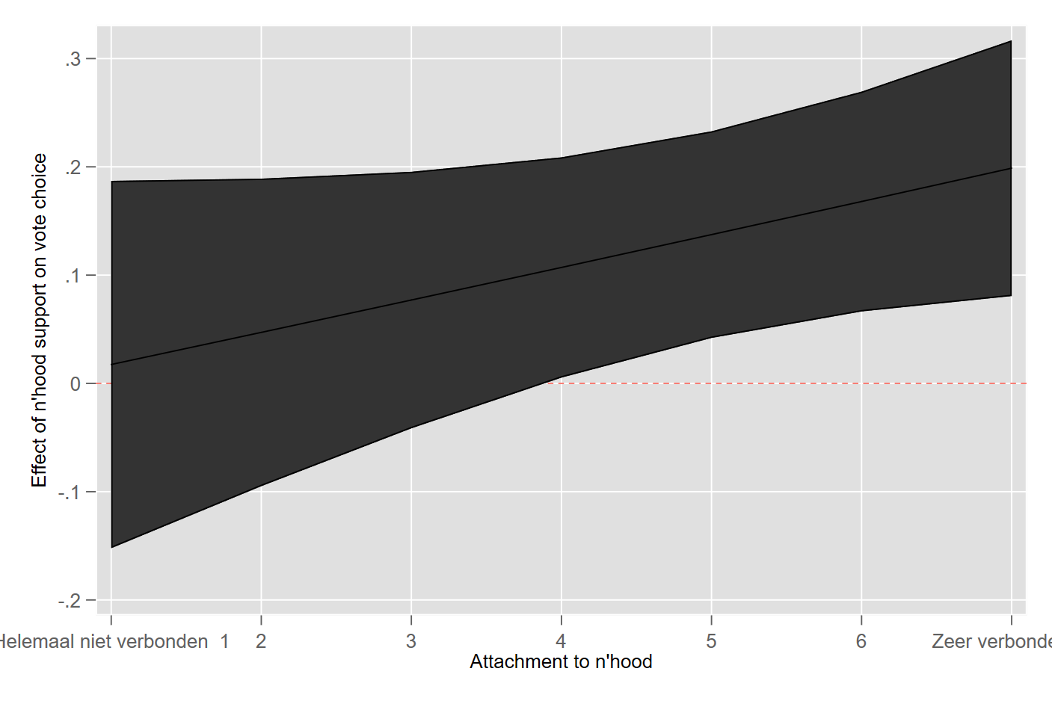

Still, logistic effects are difficult to interpret. To get an idea of the substantive size of the effects, Figure 4 presents the predicted probability to vote for a party in 2017 based on levels of neighborhood support for that party in 2012, fitted for individuals scoring 1 (not attached at all), 4 (the first score for which the neighborhood effect is significant) and 7 (very strongly attached). Among those who do not feel attached to their neighborhood, the party popularity in the neighborhood does not predict their vote choice. Among those who strongly identify with the neighborhood, it is associated with a substantive increase in the predicted probability to vote for a party: from just over 10% in neighborhoods with no support at all, to almost 16% in neighborhoods in which 20% of the voters supports a party. This is in line with H2.

*Figure 4*. Predicted probability to vote for a party, by neighborhood support and embeddedness

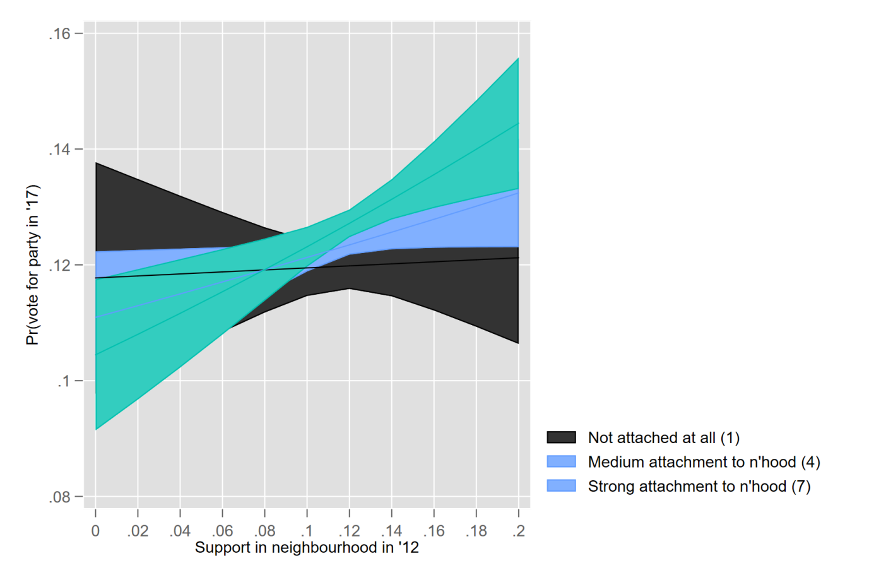

As a next step, length of residence is included. To recall, H3 posited that conversion by conversation is most likely to occur among recent arrivals that are nonetheless strongly embedded in their neighborhood. By contrast, if the homogeneity of neighborhoods is brought about primarily by geographical sorting, this is unlikely to depend on length of residence.

In Model 3 we distinguish between those who lived in the neighborhood for less than 5 years (i.e. since the last election) and more than 5 years. We re-analyzed this model using a continuous measure of length of residence, and this provided very similar results. The second-order interaction effect is not significant (*p* = 0.24). However, as always in the case of complex higher-order interactions, it is important to inspect the pattern of conditional effects visually. We do so in Figure 5.

Descriptively, Figure 5 is in line with H4: of the four fitted groups, the largest marginal effect of neighborhood support is visible among embedded individuals who only recently arrived. At the same time, the uncertainty around this effect is large, which might partly reflect the low number of recent arrivals (roughly 10% of the sample). Furthermore, the extent to which attachment matters (i.e. the difference in slopes between the two lines) appears larger among recent arrivals than longstanding residents. Nevertheless, the results are suggestive, not conclusive.

*Figure 5*. Conditional effect of neighborhood support on vote choices, by neighborhood embeddedness and length of residence

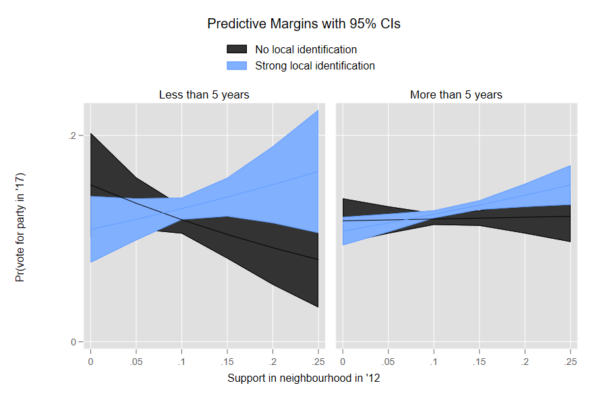

We now move to an analysis of these effects by party. Under H4, we predicted that the strongest effects would be visible for the party with the strongest stigma, the *Party of Freedom* (PVV). Figure 6 present the conditional effect of neighborhood support on vote choice for each individual party, as predicted for both low embedded respondents (1; left) and strongly embedded respondents (7; right).

*Figure 6*. Effect of neighborhood support on vote choice, by party and attachment to neighborhood (left: low, 1; right: high, 7).

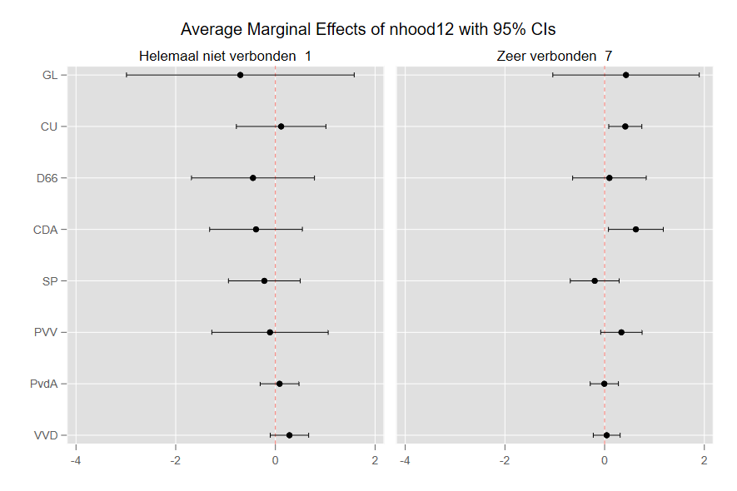

We see that among the low embedded respondents, no significant effect exists for any of the parties. Among the highly embedded respondents, the effects are descriptively largest for CU, CDA and (indeed) PVV. Following our theoretical framework, the latter could be attributed to the party’s stigma, would can be neutralized by the existence of local support. The former two could reflect social cohesion in these parties predominantly rural strongholds, which might acerbate the social costs of stepping out of line. However, this remains speculative, and at any rate few of the differences in effect between parties are significant.

Finally, we turn to possible asymmetries of the effect. Is the deterring effect of low neighborhood support as large as the encouraging effect of high support? We test this by modelling changes *towards* a party and *away from* a party as separate outcomes in a multinomial logistic regression, with not changing status (i.e., either staying with or away from a party) as the third category. This shows that only a switch *towards* a party is predicted by neighborhood support (*p* = 0.00), while a switch *away* from a party is not (*p* = 0.74). We arrive at the same conclusion if we estimate the original logistic models on the subset of voters who either did or did not support a specific party in 2012. Again, neighborhood support only predicts switching *to* a party (among those who previously did not support it), not away from a party they supported in 2012.

While the reason for this remains speculative, we think it reflects the Dutch fractioned multiparty context. High levels of support increase the likelihood converting fellow residents into support for that party. However, *low* levels of support for a party often do not involve an alternative choice presenting itself. In a two-party system, such an asymmetry is less likely, as low levels of support are always accompanied by high levels of support for an alternative. To answer this, more information is needed on the substantive content of the discussions taking place.

**Conclusions**

Common wisdom says that people are social animals, so we would expect their preferences, attitudes, values and behaviors are influenced by their social environment. So, on this basis we would expect electoral decisions to be shaped to some extent by the political preferences of their social networks, which includes friends, family, colleagues as well as neighbors. Our study focuses specifically on neighborhood effects. The idea that voting is a social act has been around since Campbell et al. published *the American Voter* in 1960 (see also, e.g., Zuckerman 2005; Huckfeld and Sprague, 1995; Huckfeld et al. 2004, Gerber et al., 2008). However, research on neighborhood effects is scarce, probably because it is difficult to obtain the data needed to estimate such effects. In this study we were able to take advantage of a unique geo-coded survey data set, which enables us to estimate the effects of electoral preferences in the neighborhood, while at the same time controlling for previous vote choice. The design is simple, but clear and the results are quite straightforward. There are clear neighborhood effects, but these effects are restricted to people who feel (strongly) embedded in the neighborhood. This effect seems strongest among those who only recently moved into the neighborhood, although the second order interaction is not significant. While the sample suggests some differences between parties, these differences are far from being statistically significant.

Many studies on neighborhood effects focus on turnout, which is visible and where social pressure might play a role (e.g., Hooghe 2017). Party choice is secret, which makes it unlikely that social pressure could play a role. The fact that the neighborhood effects that we observe are limited to those who are embedded in the neighborhood, suggests that the influence works via some forms of communication. While we are able to observe the effects, the process by which these effects occur are not visible to us. Yet, alternative mechanisms through which neighborhoods could affect the voting behavior of people who live there, seem a bit far-fetched.

One of the main problems in studying neighborhood effects is that there are all sorts of reasons why like-minded people could cluster together geographically. Some homosexuals might love to live on a farm, but many prefer to live in Berlin, Amsterdam or San Francisco. If these homosexuals also have more liberal values than the average German, Dutch or American citizen, there will be a correlation between vote choice and location. On the basis of panel survey data from the UK, Gallego et al. (2016) recently concluded that contextual effects on the vote are overestimated and are largely the result of ‘geographical sorting’: people moving into neighborhoods with like-minded people. As we arrive at a different conclusion, this raises the question why? A first difference between the two studies is that Gallego et al. employ contextual data at the level of British constituencies, with an average size of about 70,000 citizens. The neighborhoods in our study have an average size of 1,379 inhabitants. If the causal mechanism is indeed through communication, the constituency level may simply be too large.

A second difference between the studies is that, while both included a number of control variables, the study by Gallego et al. did not include moderators of contextual effects. We do find clear neighborhood effects, but only for citizens who say they feel embedded in the neighborhood.

While we consider it plausible that geographical sorting takes place in the Netherlands as well, geographical sorting does not explain the neighborhood effects. In fact, the observed effects are stronger for people who recently moved into a neighborhood, which in a way speaks against the ‘sorting’ argument. However, similar to Johnston et al. (2015), we were able to observe neighborhood effects mainly by including neighborhood embeddedness as a moderator in our model. So, future research on neighborhood effects should try to include this variable in their models.

**References**

Bishop, B. with Cushing, RG (2008). *The big sort: Why the clustering of like-minded Americans is tearing us apart*.

Books, J., & Prysby, C. (1999). Contextual effects on retrospective economic evaluations the impact of the state and local economy. *Political Behavior*, *21*(1), 1-16.

Campbell, A., Converse, P. E., Miller, W. E., and Stokes, D. E. (1960) *The American Voter*. New York: John Wiley and Sons.

Cox, K. R. 1969. The Voting Decision in a Spatial Context. *Progress in Geography* 1: 81–117.

David, Q., & Van Hamme, G. (2011). Pillars and electoral behavior in Belgium: The neighborhood effect revisited. Political geography, 30(5), 250-262.

Eijk, C. van der, W. van der Brug, M. Kroh & M. Franklin (2006), ‘Rethinking the dependent variable in electoral behavior — on the measurement and analysis of utilities’. *Electoral Studies* 25(3): 424-447.

Festinger, L. (1962). A theory of cognitive dissonance (Vol. 2). Stanford university press.

Gallego, A., F. Buscha, P. Sturgis and D. Oberski (2016), ‘Places and Preferences: A Longitudinal Analysis of Self-Selection and Contextual Effects’, *British Journal of Political Science* 46(3):529-550.

Gerber, A.S., D. Green and C. Larimer (2008), Social Pressure and Voter Turnout: Evidence from a Large-Scale Field Experiment’ , American Political Science Review 102(1):33-48.

Harteveld, Eelco, Stefan Dahlberg, Andrej Kokkonen and Wouter van der Brug (forthcoming), ‘Gender Differences in Vote Choice: Social Cues and Social Harmony as Heuristics’. Accepted by *British Journal of Political Studies*.

Hooghe, M. (2017), ‘ Social Networks and Voter Mobilization’, in: K. Arzheimer, J. Evans, M. Lewis-Beck, *The Sage Handbook of Electoral Behaviour*. London: Sage.

Huckfeld, R. and J. Sprague (1995), *Citizens, Politics and Social Communication. Information and Influence in an Election Campaign*. New York: Cambridge University Press.

Huckfeld, R. P. Johnson and J. Sprague (2004), *Political Disagreement: the Survival of Diverse Opinions in Communication Networks*. New York: Cambridge University Press.

Johnston, R. and C. Pattie (2006), *Putting Voters in their Place. Geography and Elections in Great Britain*. Oxford: Oxford University Press.

Johnston, R. and C. Pattie (2018), ‘ Local context, social networks and neighbourhood effects on voter choice’. In: J. fisher, E. Fieldhouse, M. Franklin, R. Gibson, M. Cantijoch and C. Wlezien (Eds.), *The Routledge Handbook of Elections, Voting Behavior and Public Opinion.* Oxon: Routledge.Johnston, R., Jones, K., Sarker, R., Propper, C., Burgess, S., & Bolster, A. (2004). Party support and the neighbourhood effect: spatial polarisation of the British electorate, 1991–2001. Political Geography, 23(4), 367-402.

Johnston, R., Propper, C., Sarker, R., Jones, K., Bolster, A., & Burgess, S. (2005). Neighbourhood social capital and neighbourhood effects. Environment and Planning A, 37(8), 1443-1459.

MacAllister, I., Johnston, R. J., Pattie, C. J., Tunstall, H., Dorling, D. F., & Rossiter, D. J. (2001). Class dealignment and the neighbourhood effect: Miller revisited. British journal of political science, 31(1), 41-59.

Miller, W. L. (1977). Electoral dynamics in Britain since 1918. Springer.

Mutz, D. C., & Mondak, J. J. (2006). The workplace as a context for cross-cutting political discourse. The Journal of Politics, 68(1), 140-155.

Pattie, C., & Johnston, R. (2000). ‘People who talk together vote together’: An exploration of contextual effects in Great Britain. Annals of the Association of American Geographers, 90(1), 41-66.

Taber, C. S., & Lodge, M. (2006). Motivated skepticism in the evaluation of political beliefs. American Journal of Political Science, 50(3), 755-769.

Van der Meer, T., R. Lubbe, E. van Elsas, M. Elff & W. van der Brug (2012), ‘Bounded volatility in the Dutch electoral battlefield. A panel study on changing vote intentions in a changing party system, the Netherlands 2006-2010.’ *Acta Politica* 47(4): 333-355.

Zuckerman, A.S. (2005), *The Social Logic of Politics. Personal Networks as Contexts for Political Behavior.* Philadelphia: Temple University Press.

1. 28 party lists took part in the election, of which 13 gained representation in parliament; of these, the largest (VVD) gained only obtained 21% of the votes.