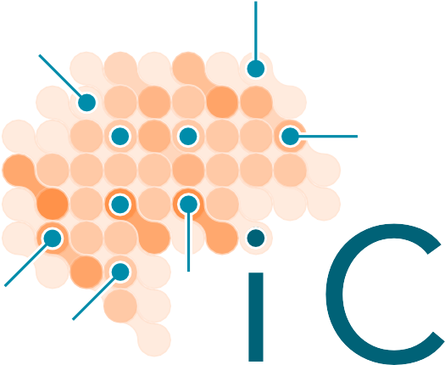





***“I learned how it is possible to crack incredibly complex problems by looking at what is happening at the cellular level.***

***This approach had already completely transformed immunology, cancer biology and developmental biology. That makes me curious if we can also apply this to the brain.”***

Karl Deisseroth, Stanford University

## Public summary

The aim of iCNS is to elucidate the molecular changes relating to psychiatric symptoms, such as depression, anxiety and psychosis. In iCNS, neurobiologists, chemists, psychiatrists and data science experts work closely together on human brain tissue. Young scientists will be trained in combining chemistry, artificial intelligence and neurobiology. Their research will lead to a “brain atlas” of psychiatric symptoms, and to entirely new approaches to improve the diagnosis, prognosis and treatment of psychiatric illnesses.

## Scientific summary

Our society faces a major mental health problem. One in four people suffer from a brain disorder that strongly impacts their quality of life and their participation in society. Neuropsychiatric disorders (psychiatric and neurological disorders), represent the number one cause of loss of years of full health (DALYs) and their annual costs amount to €798 billion in the EU. **Effective novel strategies to improve their diagnosis and treatment are currently lacking. So far, we do not know which cell types and molecular processes relate to psychiatric symptoms and psychiatric biomarkers are absent**.

Psychiatric symptoms are thought to relate to (sub-)cellular changes, ultimately leading to dysfunction(s) of brain circuits spanning different brain regions. The synapse-glia interface is one of the prime subcellular structures of interest, which is regulated by molecular processes beyond transcription, such as protein activity, post-translational modifications and protein-protein interactions. Conventional approaches to investigate disease phenotypes in human brain samples are insufficient to assess protein function at subcellular resolution and the availability of high-quality well-characterized brain material is limited. Together, this has hampered the validation and characterization of targets and novel ground- breaking approaches.

Several exciting, **revolutionary technologies** that have the potential to truly transform human brain research have emerged in chemistry and molecular biology, such as single cell transcriptomics, (chemical) proteomics, advanced microscopy, probe design (e.g., PROTACs, activity-based probes) and click chemistry. We here propose to combine the fields of Chemistry and Neuroscience by establishing the **Institute for Chemical Neuroscience** (iCNS) to improve our **understanding of the cellular and molecular changes underlying psychiatric symptoms**. In iCNS, internationally renowned neuroscientists, psychiatrists, data scientists and chemists will work closely together, building on the unparalleled collection of human brain material of extensively phenotypically characterized donors from the **Netherlands Brain Bank** (NBB).

WP1 will consolidate and expand the **psychiatric brain collection** of the NBB and set up a CSF biobank; WP2 will use **multi-omics** to create a **molecular human brain atlas**, including spatial transcriptomics, chemical proteomics and metabolomics, at single cell resolution of up to 16 brain regions across multiple neuropsychiatric disorders (i.e. major depressive disorder, bipolar disorder, schizophrenia, frontotemporal dementia, multiple sclerosis and Parkinson's disease); in WP3, a workflow of **machine learning models** will **integrate the multi-omics data and link them to psychiatric symptoms** from almost 3000 NBB donors. These data will be made open access available in the **Netherlands Neurogenomics Database**; WP4 will apply **innovative chemical methods** to study the spatiotemporal function of targets in human brain, to complement the molecular brain atlas and develop chemical probes for target validation; WP5 will develop **advanced *in vitro/vivo* model systems**, like iPSCs and brain organoids, to test and **cross-validate** selected targets using the newly developed chemical probes.

By further training a **novel generation of interdisciplinary scientists**, iCNS will hereby develop and exploit the emerging field of chemical neuroscience. We anticipate that the validated, novel targets and their complementary chemical probes will enable the future development of **innovative diagnostic biomarkers and molecular therapies** for neuropsychiatric disorders.